
Capstone Project Final Report v.1 - 04/24/2026

Why and When Do Patients
Stop Coming Back to a Hospital?
using machine learning and survival analysis.

A journey into disengagement in healthcare
- Predicting who leaves is helpful.
- Knowing when they begin to leave is powerful.
From
visits
vanishing
churn
risk
friction
missed
visit
steady
care

Student Name: Souleymane Diawara - M.S. Data Science (IT option)
Institution Name: University of Nebraska at Omaha
Graduate Program and Department: UNO / Data Science / 26SP DSCI 8950
Data Science Capstone /
Why and When Do Patients Stop Coming Back to a Hospital? using machine learning and survival analysis.
Executive Summary
This study analyzes patient churn using machine learning and survival analysis to identify key drivers and improve early detection. The results show that churn is mainly driven by engagement (recency of visits), patient satisfaction, and accessibility, while demographic factors have limited impact. Logistic Regression provided the best balance of performance and interpretability, especially when combined with threshold tuning to prioritize early detection. Survival analysis further revealed that churn risk increases over time, particularly for patients with low satisfaction and long inactivity.
Overall, the findings emphasize that effective churn management requires identifying who is at risk and when to intervene, enabling more proactive and data-driven patient retention strategies.

Abstract
Patient attrition in healthcare systems represents a complex and gradual process influenced by behavioral, experiential, and structural factors. While traditional classification approaches focus on predicting which patients are likely to churn, they often neglect the temporal dynamics underlying disengagement. This study addresses both dimensions by integrating exploratory data analysis, statistical inference, supervised machine learning, and survival analysis to provide a comprehensive framework for understanding patient churn.
Using a dataset of 2,000 patients and 21 variables encompassing demographics, engagement patterns, satisfaction scores, and financial and accessibility indicators, we first identify statistically significant differences between retained and churned patients. Although several variables exhibit strong statistical significance, effect size analysis reveals that individual predictors have only modest explanatory power, suggesting that churn is driven by the interaction of multiple factors.
We then evaluate multiple classification models, including Logistic Regression, Random Forest, XGBoost, and k-Nearest Neighbors, using cross-validation. Logistic Regression achieves the best overall performance, balancing predictive accuracy and interpretability. Finally, survival analysis is introduced to model the timing of churn, highlighting the gradual accumulation of disengagement risk.
The results demonstrate that combining predictive modeling with time-to-event analysis provides a more complete understanding of patient attrition and supports more effective intervention strategies.
1. Introduction
Patient retention is a critical challenge in healthcare systems, affecting both operational efficiency and patient outcomes. Unlike abrupt customer loss observed in other industries, patient churn typically occurs gradually, through a progressive decline in engagement, satisfaction, and interaction with healthcare providers.
Understanding this process requires addressing two fundamental questions:
- Which patients are at risk of churning?
- At what point does the risk of churn become significant?
Traditional predictive models focus primarily on the first question, treating churn as a binary classification problem. However, this approach overlooks the temporal dimension of patient disengagement, which is essential for designing timely interventions.
This study proposes an integrated analytical framework that combines:
- exploratory data analysis and statistical inference,
- supervised machine learning models, and
- survival analysis techniques
to capture both the likelihood and timing of patient churn.
The central hypothesis of this work is that patient churn is not driven by a single dominant factor but emerges from the interaction of multiple behavioral, experiential, and structural variables over time.

2. Literature Review
See references at the end of the report.
2.1 Traditional Churn Modeling
Literature Review - Article 1: Predicting Customer Churn in Telecom Using Survival Analysis (Lu, 2002)
This study by Lu (2002) represents one of the foundational applications of survival analysis to customer churn prediction. Conducted within the telecommunications industry, the research addresses a critical limitation of traditional churn models: their inability to capture the timing of customer attrition.
The study is motivated by the high economic cost of churn, noting that telecom providers experience annual churn rates of approximately 30-35%, and that acquiring new customers can cost up to ten times more than retaining existing ones. These figures underscore the importance of not only identifying at-risk customers but also understanding when they are likely to churn, which directly informs intervention strategies.
To address this, the study applies survival analysis techniques to a large dataset consisting of 41,374 high-value customers observed over a 15-month period. The dataset includes variables such as demographics, service usage, billing information, and customer contact records. Two main modeling approaches are used:
- PROC LIFETEST (non-parametric): to estimate survival curves without assuming a specific distribution
- PROC LIFEREG (parametric): to model time-to-churn under a log-normal distribution
The study focuses on estimating both the survival function (probability that a customer remains active beyond a certain time) and the hazard function (instantaneous risk of churn). These functions provide a dynamic view of churn behavior, in contrast to static classification models.
One of the key findings is that survival models can effectively rank customers based on their predicted survival probabilities, allowing organizations to prioritize retention efforts. The study demonstrates significant improvement over random selection methods, particularly in short-term prediction scenarios where timely intervention is most critical.
From a methodological perspective, the study highlights the advantage of survival analysis in handling censored data, where customers have not yet churned at the end of the observation period. This is particularly relevant in real-world settings, where not all individuals experience the event of interest within the study timeframe.
In relation to the present patient churn project, this study provides a strong conceptual foundation. Healthcare data shares many characteristics with telecom churn data, including time-dependent behavior and partial observation (patients who remain active). The study supports the idea that modeling churn as a time-to-event process enables more effective and targeted interventions.
However, a limitation of this work is its reliance on classical statistical models, which may struggle to capture complex nonlinear relationships present in modern datasets. This limitation motivates the integration of machine learning approaches in more recent research.

2.2. Survival Analysis in Churn Prediction
Literature Review - Article 2
Comparison of Classical and Machine Learning Survival Models (Lee, 2025)
Lee (2025) provides a comprehensive comparison between classical survival analysis methods and modern machine learning approaches for predicting customer retention time. Unlike earlier studies, this research explicitly evaluates the performance of both statistical and data-driven models in capturing time-to-churn dynamics.
The survival function $S(t)$represents the probability that a patient remains active beyond time $t$, while the hazard function $h(t)$captures the instantaneous risk of churn at time $t$.
These models are particularly useful in contexts where:
- not all individuals experience the event (censoring),
- time-dependent behavior is present, and
- the timing of events carries critical information.

The study is conducted in a subscription-based business context, which closely parallels the healthcare setting in terms of customer engagement and retention behavior. The primary objective is to determine which modeling framework best predicts not only whether churn will occur, but also when it is most likely to happen.
The models evaluated in the study include:
- Classical models:
  - Kaplan-Meier estimator (non-parametric)
  - Cox Proportional Hazards model (semi-parametric)
- Machine learning survival models:
  - Random Survival Forest (RSF)
  - Gradient Boosting survival models
The Kaplan-Meier method is used to estimate survival probabilities over time without incorporating covariates, while the Cox model introduces explanatory variables under the assumption of proportional hazards. These classical approaches provide interpretability but are limited in their ability to capture complex interactions.
In contrast, machine learning models such as Random Survival Forest extend traditional tree-based methods to survival data. These models can handle nonlinear relationships, interactions between variables, and high-dimensional data more effectively than classical approaches.
The results of the study indicate that Random Survival Forest achieves the best overall performance, outperforming both Cox models and parametric methods. Specifically, RSF demonstrates:
- higher predictive accuracy
- improved robustness to outliers
- better handling of complex feature interactions
Another important contribution of this study is the emphasis on time-varying covariates, which reflect changes in customer behavior over time. Incorporating such variables significantly improves predictive performance, as churn risk is inherently dynamic.
The study also highlights the importance of evaluating models using appropriate metrics for survival data, such as prediction error measures and time-dependent accuracy, rather than relying solely on traditional classification metrics.
For the patient churn project, this research is highly relevant. Variables such as days since last visit, missed appointments, and satisfaction scores naturally evolve over time and can be interpreted as time-dependent features. The study supports the extension of classical survival models toward more flexible machine learning approaches.
However, while machine learning models offer superior predictive performance, they often sacrifice interpretability, which remains an important consideration in healthcare applications. This reinforces the need for a balanced approach that considers both accuracy and explainability.

2.3 Machine Learning Approaches
Machine learning approaches have become central to churn prediction due to their ability to model complex, nonlinear relationships and interactions among variables. In contrast to traditional statistical methods, which rely on predefined functional forms and assumptions (like linearity, independence), machine learning models learn patterns directly from the data, making them particularly well-suited for high-dimensional and behavior-driven datasets.
In churn prediction contexts, commonly used machine learning models include Logistic Regression, k-Nearest Neighbors (KNN), Random Forest, and Gradient Boosting. Ensemble methods such as Random Forest and boosting algorithms are especially effective because they aggregate multiple decision trees, allowing them to capture nonlinearities and variable interactions that simpler models may overlook. As highlighted in prior research, these models often achieve superior performance in terms of accuracy, recall, and ROC AUC, particularly when churn behavior is influenced by multiple weak predictors acting jointly.
However, the empirical results of this study-and similar findings in the literature-suggest that more complex models do not always yield substantially better performance. In the present analysis, although ensemble methods such as Random Forest and XGBoost demonstrated strong specificity, they exhibited relatively poor sensitivity, limiting their ability to detect churners. This highlights an important limitation: complex models may overfit dominant patterns in imbalanced datasets, favoring the majority class and failing to adequately identify minority outcomes such as churn.
In this context, Logistic Regression remains a highly competitive baseline model, particularly when combined with appropriate preprocessing and threshold tuning. Despite its simplicity, logistic regression offers several advantages:
- Interpretability: model coefficients provide direct insight into the direction and magnitude of variable effects
- Stability: less sensitive to noise and overfitting compared to highly flexible models
- Probabilistic output: produces calibrated probabilities that can be adjusted based on decision thresholds
A key factor explaining the strong performance of logistic regression in this study is the use of threshold tuning. By default, classification models assign observations to classes using a probability threshold of 0.5. However, in imbalanced datasets, this threshold may not be optimal. Lowering the threshold increases sensitivity (true positive rate) at the expense of specificity, allowing the model to identify a larger proportion of churned patients.
This trade-off is particularly important in healthcare applications, where the cost of failing to identify a patient at risk of churn may be significantly higher than the cost of a false positive. By tuning the classification threshold, logistic regression can be adapted to prioritize early detection of at-risk patients, even if it leads to reduced specificity.
Furthermore, the relatively modest effect sizes observed in the statistical analysis suggest that churn is driven by the additive contribution of multiple weak predictors, rather than by strong nonlinear interactions. In such settings, simpler linear models can perform comparably to, or even better than, more complex models that attempt to capture interactions that may not be sufficiently strong or stable in the data.
In summary, while machine learning models provide powerful tools for capturing complex patterns, their performance must be evaluated in light of the data structure, class imbalance, and application context. This study demonstrates that a well-specified and properly tuned logistic regression model can outperform more complex alternatives, offering a strong balance between predictive performance, interpretability, and practical usability.

2.4 Integrating Predictive and Temporal Modeling
More recent studies emphasize the complementary nature of classification and survival analysis. While classification models identify high-risk individuals, survival models provide insight into how risk evolves over time, enabling more effective intervention strategies.
This integrated perspective forms the methodological foundation of the present study.

3. Data Description
This Patient Churn prediction dataset in healthcare is a dataset designed for binary classification tasks to predict patient attrition (churn). Originally download from Kaggle, it contains 2000 patient records with 21 variables covering demographics, service utilization, satisfaction scores, and financial/engagement. The target variable is the binary column “Churn” (1 = Churned, 0 = still active, receiving care there).

3.1 Variable Categories
The dataset used in this study consists of 21 variables capturing multiple dimensions of patient behavior, experience, and access to care. These variables can be broadly categorized into five groups: demographic, engagement/behavioral, satisfaction, financial/access, and temporal features. Each category reflects a different aspect of the patient journey and contributes uniquely to understanding churn dynamics. While individual variables provide specific signals, grouping them conceptually allows for a more structured interpretation of patient disengagement.

The 21 columns of the dataset are PatientID, Age, Gender, State, Tenure_Months, Specialty, Insurance_Type, Visits_Last_Year, Missed_Appointments, Days_Since_Last_Visit, Last_Interaction_Date, Overall_Satisfaction, Wait_Time_Satisfaction, Staff_Satisfaction, Provider_Rating, Avg_Out_Of_Pocket_Cost, Billing_Issues, Portal_Usage, Referrals_Made, Distance_To_Facility_Miles, Churned.

Demographic Variables
Demographic features include variables such as Age, Gender, and State. These variables describe the baseline characteristics of patients and are often used in segmentation analyses.
- Age captures life stage differences that may influence healthcare needs and engagement patterns. For example, younger patients may exhibit more sporadic engagement, while older patients may require more consistent care.
- Gender provides insight into potential behavioral differences in healthcare utilization, although in many churn studies, gender tends to show limited predictive power.
- State (or geographic location) may reflect regional differences in healthcare access, provider availability, or socioeconomic conditions.
Despite their intuitive relevance, demographic variables are generally considered weak predictors of churn in isolation. In this dataset, exploratory analysis suggests that churn rates remain relatively stable across demographic groups, indicating that who the patient is matters less than how the patient behaves.

Engagement and Behavioral Variables
Engagement-related variables are among the most informative predictors of churn, as they directly capture patient interaction with the healthcare system. Key variables include:
- Visits_Last_Year: measures the frequency of patient interactions with healthcare providers. Lower visit frequency may indicate declining engagement.
- Missed_Appointments: reflects unreliability or disengagement. Higher values are often associated with increased churn risk.
- Portal_Usage: indicates whether the patient actively uses digital tools to manage their care. Lower usage suggests weaker engagement and reduced connection to the healthcare system.
These variables can be grouped under a broader construct of patient engagement intensity, which reflects how actively a patient participates in their care. Declining engagement is often an early signal of churn, making this category particularly valuable for predictive modeling.

Satisfaction Variables
Satisfaction metrics capture the patient’s subjective experience with healthcare services. These variables typically include:
- Overall_Satisfaction: a composite measure of patient experience.
- Wait_Time_Satisfaction: reflects patient perception of service efficiency.
- Staff_Satisfaction: captures interactions with healthcare personnel.
- Provider_Rating: evaluates satisfaction with the medical provider.
These variables are measured on ordinal scales (e.g., 1-5) and provide insight into experience quality. Lower satisfaction scores are consistently associated with higher churn risk, as dissatisfied patients are more likely to seek alternative providers.
Conceptually, these variables can be grouped into a latent construct of patient experience quality, which plays a central role in retention. Unlike behavioral variables, which capture actions, satisfaction variables capture perceptions, making them complementary indicators of churn risk.

Financial and Access Variables
Financial and structural barriers are represented by variables such as:
- Avg_Out_Of_Pocket_Cost: reflects the financial burden on the patient. Higher costs may discourage continued engagement.
- Distance_To_Facility_Miles: measures geographic accessibility. Greater distance can reduce visit frequency and increase churn likelihood.
- Billing_Issues: indicates administrative friction that may negatively impact patient experience.
These variables can be grouped under accessibility and cost constraints, representing external factors that influence a patient’s ability to maintain consistent care. Unlike satisfaction variables, which reflect internal perceptions, these variables capture structural limitations that may push patients toward disengagement.

Temporal Variables
Temporal features describe the timing and duration of patient interactions:
- Tenure_Months: measures the length of the patient-provider relationship. Longer tenure is generally associated with higher retention due to established trust and continuity of care.
- Days_Since_Last_Visit: captures recency of engagement. Larger values indicate inactivity and are strong predictors of churn.
These variables are particularly important because they introduce a time dimension into the analysis. They can be grouped into a construct of engagement recency and relationship duration, which reflects both how recently and how consistently a patient interacts with the healthcare system.
Temporal variables are also critical for survival analysis, as they align naturally with time-to-event modeling and allow for the estimation of churn risk over time.

Conceptual Grouping of Variables
While individual variables provide specific insights, grouping them into higher-level constructs enhances interpretability and aligns with theoretical frameworks of churn. The dataset can be summarized into the following conceptual dimensions:
- Patient Profile: Age, Gender, State
- Engagement Behavior: Visits_Last_Year, Missed_Appointments, Portal_Usage
- Experience Quality: Overall_Satisfaction, Wait_Time_Satisfaction, Staff_Satisfaction, Provider_Rating
- Access and Cost Constraints: Avg_Out_Of_Pocket_Cost, Distance_To_Facility_Miles, Billing_Issues
- Temporal Dynamics: Tenure_Months, Days_Since_Last_Visit
This grouping highlights that churn is not driven by a single variable but rather by the interaction of multiple dimensions. In particular, the combination of declining engagement, poor experience, and structural barriers creates conditions under which patients gradually disengage from care.
Let’s observe the first and last few observations
head(df, 3)
## PatientID Age Gender State Tenure_Months Specialty Insurance_Type
## 1 C20000 41 Female PA 62 Pediatrics Medicaid
## 2 C20001 43 Female GA 44 Internal Medicine Self-Pay
## 3 C20002 21 Male MI 120 Internal Medicine Medicaid
## Visits_Last_Year Missed_Appointments Days_Since_Last_Visit
## 1 1 0 564
## 2 7 4 254
## 3 15 5 89
## Last_Interaction_Date Overall_Satisfaction Wait_Time_Satisfaction
## 1 2024-07-05 3.5 4.9
## 2 2025-05-11 2.6 3.1
## 3 2025-10-23 1.6 4.4
## Staff_Satisfaction Provider_Rating Avg_Out_Of_Pocket_Cost Billing_Issues
## 1 3.8 4.2 306 0
## 2 4.7 4.3 1851 0
## 3 2.1 4.7 391 0
## Portal_Usage Referrals_Made Distance_To_Facility_Miles Churned
## 1 0 3 21.4 1
## 2 0 0 47.6 1
## 3 0 2 7.1 0
tail(df, 3)
## PatientID Age Gender State Tenure_Months Specialty Insurance_Type
## 1998 C21997 37 Male NC 91 Family Medicine Medicare
## 1999 C21998 69 Female NY 5 Internal Medicine Private
## 2000 C21999 63 Female NC 69 Family Medicine Private
## Visits_Last_Year Missed_Appointments Days_Since_Last_Visit
## 1998 9 4 494
## 1999 3 0 315
## 2000 6 2 675
## Last_Interaction_Date Overall_Satisfaction Wait_Time_Satisfaction
## 1998 2024-09-13 3.9 2.7
## 1999 2025-03-11 1.7 3.2
## 2000 2024-03-16 2.3 3.4
## Staff_Satisfaction Provider_Rating Avg_Out_Of_Pocket_Cost Billing_Issues
## 1998 3.0 2.7 50 0
## 1999 3.6 4.2 848 0
## 2000 4.0 4.9 1310 0
## Portal_Usage Referrals_Made Distance_To_Facility_Miles Churned
## 1998 1 3 2.6 0
## 1999 0 1 38.8 1
## 2000 0 1 48.2 1

The dataset provides a comprehensive representation of patient behavior and experience. While demographic variables offer limited predictive value, engagement, satisfaction, financial, and temporal features collectively capture the multi-dimensional nature of churn. Grouping variables into conceptual categories not only improves interpretability but also supports the development of more robust predictive models by aligning features with underlying behavioral mechanisms.

3.2 Data Quality
colSums(is.na(df))
## PatientID Age
## 0 0
## Gender State
## 0 0
## Tenure_Months Specialty
## 0 0
## Insurance_Type Visits_Last_Year
## 0 0
## Missed_Appointments Days_Since_Last_Visit
## 0 0
## Last_Interaction_Date Overall_Satisfaction
## 0 0
## Wait_Time_Satisfaction Staff_Satisfaction
## 0 0
## Provider_Rating Avg_Out_Of_Pocket_Cost
## 0 0
## Billing_Issues Portal_Usage
## 0 0
## Referrals_Made Distance_To_Facility_Miles
## 0 0
## Churned
## 0
No missing values.
The dataset used in this study is notably clean, with no missing values and no duplicate records detected during the initial inspection. This level of data quality simplifies preprocessing and allows the analysis to focus directly on modeling and interpretation. However, in most real-world healthcare and customer analytics datasets, issues such as missing data and duplicated observations are common and can significantly affect model performance if not handled properly. Therefore, it is important to outline standard methodologies and algorithms used to address these issues.

3.2.1 Handling Missing Data
Missing data is one of the most frequent challenges in applied data science. It can arise from data entry errors, system limitations, or incomplete patient records. The treatment of missing values depends on both the mechanism of missingness and the importance of the affected variable.
Types of Missingness
Before applying any method, it is essential to understand the nature of missing data:
- Missing Completely at Random (MCAR): missingness is independent of both observed and unobserved data
- Missing at Random (MAR): missingness depends on observed variables
- Missing Not at Random (MNAR): missingness depends on unobserved factors
The choice of imputation strategy depends on which assumption is most plausible.

Common Methods for Handling Missing Data
- Deletion Methods: Listwise deletion: remove observations with any missing value. These methods are simple but can lead to loss of information and potential bias if missingness is not random.
- Simple Imputation Techniques: Mean/Median Imputation (numerical variables), Mode Imputation (categorical variables). These methods are easy to implement but may reduce variability and distort distributions.
- K-Nearest Neighbors (KNN) Imputation: replaces missing values based on the values of similar observations. It preserves local structure in the data. Particularly useful when relationships between variables are strong.
- Regression Imputation: predicts missing values using regression models. This can incorporate multiple predictors. More flexible than simple imputation but may underestimate uncertainty.
- Multiple Imputation (MICE - Multivariate Imputation by Chained Equations): generates multiple imputed datasets. accounts for uncertainty in missing values. Considered one of the most robust approaches for statistical inference.
- Model-Based Imputation: algorithms such as Random Forest or Gradient Boosting can be used to predict missing values. Captures nonlinear relationships. Increasingly popular in machine learning pipelines.
- Indicator Method: adds a binary variable indicating whether a value was missing. Useful when missingness itself carries information (e.g., missing visits may indicate disengagement).

3.2.2 Handling Duplicate Data
sum(duplicated(df))
## [1] 0
There is no duplicate records. No duplicate observations were detected, and no missing data across variables, suggesting minimal risk of bias from incomplete data.

Duplicate records can arise from data integration processes, repeated entries, or system synchronization issues. These duplicates can bias statistical estimates and inflate the importance of certain observations.
Detection of Duplicates
Common methods include:
- Exact matching: identifying rows with identical values across all columns
- Key-based matching: using unique identifiers such as PatientID
Methods for Handling Duplicates
If duplicate data was found, we could have handle it by multiple methods:
  - simple Removal: consisting on removing the exact duplicates using functions such as duplicated(). This is most appropriate when duplicates are clearly redundant.
  - by aggregation which is combining duplicate records by averaging or summing values. This is useful when duplicates represent repeated measurements.

By applying the Rule-Based Selection, we will retain the most recent or most complete record. It will requires domain knowledge.
In this dataset, no missing values or duplicates were identified, which eliminates the need for imputation or deduplication procedures. However, understanding these methods remains essential, as:
- real-world healthcare datasets often contain incomplete records
- improper handling of missing data can introduce bias
- duplicate records can distort model training and evaluation

Although the dataset used in this study is clean, robust data preprocessing strategies are critical in general applications. Techniques such as multiple imputation, KNN imputation, and model-based methods provide effective solutions for missing data, while duplicate detection and resolution ensure data integrity. These preprocessing steps are foundational for building reliable and unbiased predictive models.

3.3 Class Distribution
Understanding the distribution of the target variable is a critical step in any predictive modeling task, particularly in classification problems such as patient churn. In this study, the target variable Churned exhibits a clear imbalance, with approximately 68% of patients classified as churned and 32% retained. This distribution indicates that the dataset is moderately imbalanced, with the churned class representing the majority outcome.
To visualize this imbalance, a bar chart illustrating the frequency and proportion of each class is provided below.
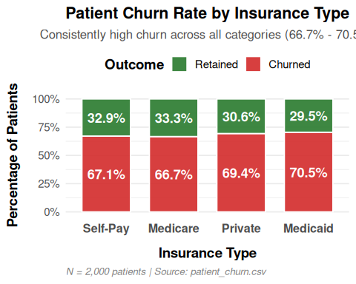
Figure 3.3: bar chart showing percentage of “Churned” vs “Retained” patients

This imbalance has important implications for both model training and evaluation. In classification tasks, many algorithms are designed to optimize overall accuracy. However, in imbalanced settings, a model can achieve relatively high accuracy by simply predicting the majority class. For example, a naïve classifier that predicts all patients as churned would achieve an accuracy of approximately 68%, despite providing no meaningful predictive insight.

3.3.1 Impact of Class Imbalance on Modeling
Class imbalance affects model performance in several ways:
- Bias Toward the Majority Class
Models tend to favor the dominant class (churned), leading to high sensitivity but low specificity, or vice versa depending on the learning objective.
- Misleading Performance Metrics
Accuracy becomes less informative, as it does not capture the model’s ability to distinguish between classes. Metrics such as precision, recall, F1-score, and ROC AUC become more appropriate.
- Poor Minority Class Detection
The minority class (retained patients in this case) may be underrepresented during training, leading to weaker predictive performance for that group.
- Threshold Sensitivity
The choice of classification threshold becomes critical, as small adjustments can significantly change sensitivity and specificity.

The influence of class imbalance is evident in the model results:
- Some models (e.g., Random Forest) exhibit high specificity but very low sensitivity, indicating difficulty in identifying churned patients correctly.
- Logistic Regression, when tuned, shows high sensitivity but low specificity, reflecting a bias toward predicting churn.
These patterns highlight the trade-off between identifying churners (true positives) and avoiding false alarms (false positives).

Several strategies can be employed to mitigate the effects of class imbalance:
1. Data-Level Approaches (Resampling Techniques)
- Oversampling the minority class
  - Like Random oversampling, SMOTE (Synthetic Minority Over-sampling Technique)
  - increases representation of underrepresented class
- Undersampling the majority class
  - reduces the size of the dominant class
  - may lead to loss of information if not applied carefully
- Hybrid methods
  - combine oversampling and undersampling for balance

2. Algorithm-Level Approaches
- Class weighting
  - assign higher penalty to misclassification of minority class
  - commonly used in logistic regression and tree-based models
- Cost-sensitive learning
  - explicitly define higher cost for false negatives or false positives
Although the dataset exhibits class imbalance, with approximately 68% churned and 32% retained patients, this level of imbalance is considered moderate and does not necessarily justify the use of synthetic resampling techniques such as SMOTE. In this study, the modeling results indicate that the algorithms are already capable of learning meaningful patterns from the minority class without the need to artificially generate additional observations. Moreover, applying SMOTE may introduce synthetic data points that do not fully reflect the true underlying distribution, potentially affecting model calibration and interpretability - both of which are critical in a healthcare context. Instead, this study adopts alternative strategies better suited to moderate imbalance, including the use of robust evaluation metrics such as ROC AUC and sensitivity, as well as threshold tuning to prioritize the detection of at-risk patients. This approach preserves the integrity of the original data while effectively addressing the imbalance in a manner aligned with the study’s objectives.
3. Threshold Tuning
Instead of using the default probability threshold (0.5), the classification threshold can be adjusted to optimize specific objectives:
- lower threshold → higher sensitivity (detect more churners)
- higher threshold → higher specificity
This approach is particularly useful when the cost of missing a churned patient is high.

4. Evaluation Strategy
Use appropriate metrics that account for imbalance:
- ROC AUC: evaluates overall discrimination
- Precision-Recall curve: more informative when classes are imbalanced
- F1-score: balances precision and recall

3.3.3 Implications for This Study
Given the healthcare context, identifying patients at risk of churn is often more critical than minimizing false positives. Missing a churned patient may result in loss of care continuity, whereas incorrectly flagging a retained patient may only incur a minor intervention cost.
Therefore, the modeling strategy in this study prioritizes:
- sensitivity (recall for churned patients)
- balanced evaluation metrics such as ROC AUC
- threshold tuning to align with operational objectives

The class distribution in this dataset reveals a moderate imbalance that significantly influences model behavior and evaluation. While not extreme, this imbalance requires careful consideration in both model selection and performance interpretation. By applying appropriate techniques such as resampling, class weighting, and threshold tuning, it is possible to mitigate these effects and develop models that better capture the underlying churn dynamics.

4. Exploratory Data Analysis
Exploratory analysis reveals several consistent patterns across key variables.
4.1 Check outliers
# Let's find outliers for a couple features: Age,Tenure_Months, Missed_Appointments, Overall_Satisfaction
findOutliers_by_iqr(df, "Age")
## integer(0)
findOutliers_by_iqr(df, "Tenure_Months")
## integer(0)
findOutliers_by_iqr(df, "Missed_Appointments")
## integer(0)
findOutliers_by_iqr(df, "Overall_Satisfaction")
## integer(0)
findOutliers_by_iqr(df, "Distance_To_Facility_Miles")
## integer(0)
No outliers found on: Age,Tenure Months, Missed Appointments, Overall Satisfaction and Distance To Facility Miles.

4.2 Data Preprocessing
Because the dataset has some numerical columns with different units, Scaling is important to standardization the columns

num_cols <- df %>% select_if(is.numeric) %>% select(-Churned) %>% names() # exclude target Variable
num_cols
## [1] "Age" "Tenure_Months"
## [3] "Visits_Last_Year" "Missed_Appointments"
## [5] "Days_Since_Last_Visit" "Overall_Satisfaction"
## [7] "Wait_Time_Satisfaction" "Staff_Satisfaction"
## [9] "Provider_Rating" "Avg_Out_Of_Pocket_Cost"
## [11] "Billing_Issues" "Portal_Usage"
## [13] "Referrals_Made" "Distance_To_Facility_Miles"
#building a new dataset df_standard (I did not forget to add the target column temp. removed)
df_standard <- data.frame(scale(df[num_cols]), Churned = df$Churned)
head(df_standard)
## Age Tenure_Months Visits_Last_Year Missed_Appointments
## 1 -0.7486825 0.03607102 -1.4156245 -1.1934245
## 2 -0.6223918 -0.47658456 -0.1314172 1.1604699
## 3 -2.0115889 1.68796120 1.5808592 1.7489435
## 4 0.7668052 1.63099947 0.5106864 0.5719963
## 5 -2.2010248 0.26391794 -0.5594863 1.1604699
## 6 0.7668052 0.60568832 1.5808592 -0.6049509
## Days_Since_Last_Visit Overall_Satisfaction Wait_Time_Satisfaction
## 1 0.9294459 0.2429122 1.5956395
## 2 -0.5267032 -0.6494183 -0.1881945
## 3 -1.3017504 -1.6408967 1.1001301
## 4 -1.0856766 -0.6494183 1.0010282
## 5 1.5494836 -1.0460097 0.7037225
## 6 1.2347675 -1.5417489 1.5956395
## Staff_Satisfaction Provider_Rating Avg_Out_Of_Pocket_Cost Billing_Issues
## 1 0.3144745 0.6322335 -0.90070504 -0.2917955
## 2 1.3470429 0.7685201 1.72224290 -0.2917955
## 3 -1.6359327 1.3136664 -0.75640047 -0.2917955
## 4 0.8881236 1.5862396 -0.04845918 -0.2917955
## 5 0.6586640 0.9048067 0.05000748 -0.2917955
## 6 -1.4064730 1.1773799 1.20783952 -0.2917955
## Portal_Usage Referrals_Made Distance_To_Facility_Miles Churned
## 1 -0.5092309 1.3784467 -0.2700977 1
## 2 -0.5092309 -1.3484509 1.6082695 1
## 3 -0.5092309 0.4694809 -1.2953135 0
## 4 -0.5092309 -1.3484509 -0.9726931 1
## 5 -0.5092309 -1.3484509 -1.0658946 1
## 6 1.9627638 -0.4394850 -1.4028536 0

4.3. Data Analysis and Visualization
4.3.1 Univariate Analysis
4.3.1.1 Categorical Data Counts
The categorical variables are: - Gender - State - Specialty - Insurance_Type - Portal_Usage (binary but categorical) - Billing_Issues (binary) - Churned (target, categorical)
## Gender n Relative_Frequency Percentage Variable Insurance_Type
## 1 Male 1016 0.5080 50.80 Gender <NA>
## 2 Female 984 0.4920 49.20 Gender <NA>
## 3 <NA> 523 0.2615 26.15 Insurance_Type Self-Pay
## 4 <NA> 516 0.2580 25.80 Insurance_Type Medicare
## 5 <NA> 483 0.2415 24.15 Insurance_Type Private
## 6 <NA> 478 0.2390 23.90 Insurance_Type Medicaid
## 7 <NA> 302 0.1510 15.10 Specialty <NA>
## 8 <NA> 289 0.1445 14.45 Specialty <NA>
## 9 <NA> 289 0.1445 14.45 Specialty <NA>
## 10 <NA> 286 0.1430 14.30 Specialty <NA>
## 11 <NA> 284 0.1420 14.20 Specialty <NA>
## 12 <NA> 277 0.1385 13.85 Specialty <NA>
## 13 <NA> 273 0.1365 13.65 Specialty <NA>
## 14 <NA> 259 0.1295 12.95 State <NA>
## 15 <NA> 214 0.1070 10.70 State <NA>
## 16 <NA> 213 0.1065 10.65 State <NA>
## 17 <NA> 205 0.1025 10.25 State <NA>
## 18 <NA> 197 0.0985 9.85 State <NA>
## 19 <NA> 193 0.0965 9.65 State <NA>
## 20 <NA> 184 0.0920 9.20 State <NA>
## 21 <NA> 181 0.0905 9.05 State <NA>
## 22 <NA> 180 0.0900 9.00 State <NA>
## 23 <NA> 174 0.0870 8.70 State <NA>
## 24 <NA> 1588 0.7940 79.40 Portal_Usage <NA>
## 25 <NA> 412 0.2060 20.60 Portal_Usage <NA>
## 26 <NA> 1843 0.9215 92.15 Billing_Issues <NA>
## 27 <NA> 157 0.0785 7.85 Billing_Issues <NA>
## 28 <NA> 1367 0.6835 68.35 Churned <NA>
## 29 <NA> 633 0.3165 31.65 Churned <NA>
## Specialty State Portal_Usage Billing_Issues Churned
## 1 <NA> <NA> NA NA NA
## 2 <NA> <NA> NA NA NA
## 3 <NA> <NA> NA NA NA
## 4 <NA> <NA> NA NA NA
## 5 <NA> <NA> NA NA NA
## 6 <NA> <NA> NA NA NA
## 7 General Practice <NA> NA NA NA
## 8 Family Medicine <NA> NA NA NA
## 9 Orthopedics <NA> NA NA NA
## 10 Neurology <NA> NA NA NA
## 11 Pediatrics <NA> NA NA NA
## 12 Internal Medicine <NA> NA NA NA
## 13 Cardiology <NA> NA NA NA
## 14 <NA> NC NA NA NA
## 15 <NA> IL NA NA NA
## 16 <NA> FL NA NA NA
## 17 <NA> PA NA NA NA
## 18 <NA> NY NA NA NA
## 19 <NA> OH NA NA NA
## 20 <NA> CA NA NA NA
## 21 <NA> GA NA NA NA
## 22 <NA> TX NA NA NA
## 23 <NA> MI NA NA NA
## 24 <NA> <NA> 0 NA NA
## 25 <NA> <NA> 1 NA NA
## 26 <NA> <NA> NA 0 NA
## 27 <NA> <NA> NA 1 NA
## 28 <NA> <NA> NA NA 1
## 29 <NA> <NA> NA NA 0
library(knitr)
freq_df %>%
arrange(Variable, desc(n)) %>%
kable(digits = 3)
Gender | n | Relative_Frcy | Percentage | Variable | Insurance_Type | Specialty | State | Portal_Usage | Billing_Issues | Churned
NA | 1843 | 0.921 | 92.15 | Billing_Issues | NA | NA | NA | NA | 0 | NA
NA | 157 | 0.078 | 7.85 | Billing_Issues | NA | NA | NA | NA | 1 | NA
NA | 1367 | 0.683 | 68.35 | Churned | NA | NA | NA | NA | NA | 1
NA | 633 | 0.316 | 31.65 | Churned | NA | NA | NA | NA | NA | 0
Male | 1016 | 0.508 | 50.80 | Gender | NA | NA | NA | NA | NA | NA
Female | 984 | 0.492 | 49.20 | Gender | NA | NA | NA | NA | NA | NA
NA | 523 | 0.262 | 26.15 | Insurance_Type | Self-Pay | NA | NA | NA | NA | NA
NA | 516 | 0.258 | 25.80 | Insurance_Type | Medicare | NA | NA | NA | NA | NA
NA | 483 | 0.242 | 24.15 | Insurance_Type | Private | NA | NA | NA | NA | NA
NA | 478 | 0.239 | 23.90 | Insurance_Type | Medicaid | NA | NA | NA | NA | NA
NA | 1588 | 0.794 | 79.40 | Portal_Usage | NA | NA | NA | 0 | NA | NA
NA | 412 | 0.206 | 20.60 | Portal_Usage | NA | NA | NA | 1 | NA | NA
NA | 302 | 0.151 | 15.10 | Specialty | NA | General Practice | NA | NA | NA | NA
NA | 289 | 0.144 | 14.45 | Specialty | NA | Family Medicine | NA | NA | NA | NA
NA | 289 | 0.144 | 14.45 | Specialty | NA | Orthopedics | NA | NA | NA | NA
NA | 286 | 0.143 | 14.30 | Specialty | NA | Neurology | NA | NA | NA | NA
NA | 284 | 0.142 | 14.20 | Specialty | NA | Pediatrics | NA | NA | NA | NA
NA | 277 | 0.138 | 13.85 | Specialty | NA | Internal Medicine | NA | NA | NA | NA
NA | 273 | 0.136 | 13.65 | Specialty | NA | Cardiology | NA | NA | NA | NA
NA | 259 | 0.130 | 12.95 | State | NA | NA | NC | NA | NA | NA
NA | 214 | 0.107 | 10.70 | State | NA | NA | IL | NA | NA | NA
NA | 213 | 0.106 | 10.65 | State | NA | NA | FL | NA | NA | NA
NA | 205 | 0.102 | 10.25 | State | NA | NA | PA | NA | NA | NA
NA | 197 | 0.098 | 9.85 | State | NA | NA | NY | NA | NA | NA
NA | 193 | 0.096 | 9.65 | State | NA | NA | OH | NA | NA | NA
NA | 184 | 0.092 | 9.20 | State | NA | NA | CA | NA | NA | NA
NA | 181 | 0.090 | 9.05 | State | NA | NA | GA | NA | NA | NA
NA | 180 | 0.090 | 9.00 | State | NA | NA | TX | NA | NA | NA
NA | 174 | 0.087 | 8.70 | State | NA | NA | MI | NA | NA | NA

Interpretation
#Not finish
df %>%
mutate(Churned = factor(Churned, labels = c("Stayed", "Churned"))) %>%
ggplot(aes(x = Churned)) +
geom_bar(aes(y = after_stat(prop)))
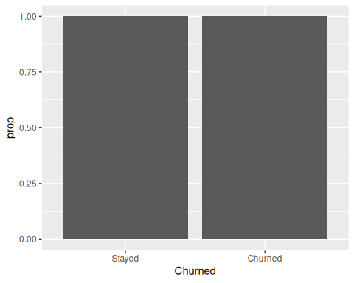
The distribution shows that a majority of patients have churned (around 63%), indicating a noticeable class imbalance in the dataset.
Distribution
Gender distribution (male: 50.8%, female: 49.2%): the dataset is well balanced by gender, so gender bias is unlikely to distort the churn model. This is good for modeling reliability.
Insurance type can be a very important driver: - self-pay: 26.15% (largest) - medicare: 25.8% - private: 24.15% - medicaid: 23.9%
This is a very evenly distributed variable, but self-pay being the largest group is a red flag typically, self-pay patients are more price-sensitive
We will have this hypothesis: self-pay patients are more likely to churn due to financial pressure.
Specialty distribution: - general practice: 15.1% - family medicine: 14.45% - orthopedics: 14.45% - neurology: 14.3% - pediatrics: 14.2% - internal medicine: 13.85% - cardiology: 13.65%
We can see here that the distribution is very uniform across specialties. We can observer that no single specialty dominates. So the churn differences across specialties will likely be behavioral, not due to sample imbalance. That being say, we can safely compare specialties.
State distribution The data is not only patients attending one medical facility but across multiple state - NC for North Carolina: 12.95% - IL for Illinois: 10.7% - FL for Florida: 10.65% - PA for Pennsylvania: 10.25% - NY for New York: 9.85% - and other states like OH-Ohio, CA-California, GA-Georgia, TX-Texas, MI-Michigan are around 9%.
All 10 states are moderately balanced, but NC is slightly overrepresented, but we have no extreme geographic skew. In this picture, the geographic variation exists but is not dominant, but it is still worth testing for regional churn patterns.
Portal usage (No usage (0): 79.4%, Usage (1): 20.6%).
This is a very strong signal since our data is highly imbalanced. This means most patients are not digitally engaged.
The hypothesis: - (Ho) patients who use the portal are more engaged - (H1) non-users are more likely to churn
If this is true, Portal usage will likely be one of the top predictive features
Billing issues (no issues (0): 92.15%, issues (1): 7.85%)
This event about billing is very skewed. Even though rare, billing issues may have a disproportionate impact on churn. Some complication with billing will always get the patients with financial strain to likely churn (high-impact variable), regarless of the low-frequency.
Churn (churned (1): 68.35%, Not churned (0): 31.65%)
This is the target variable but the proportion shows an imbalanced group: - majority of patients have churned
This means on analyzing and modeling, class weighting and resampling (smote) needs to be addressed.
For the business insight: Patient retention is a serious issue in this dataset. Loosing almost 70% of patients have a significant impact on establishment budgeting, personal.
df %>%
group_by(Insurance_Type, Churned) %>%
summarise(Frequency = n(), .groups = "drop") %>%
group_by(Insurance_Type) %>%
mutate(
Relative_Frequency = Frequency / sum(Frequency),
Percentage = round(Relative_Frequency * 100, 2)
) %>%
arrange(Insurance_Type, desc(Churned))
## # A tibble: 8 × 5
## # Groups: Insurance_Type [4]
## Insurance_Type Churned Frequency Relative_Frequency Percentage
## <chr> <int> <int> <dbl> <dbl>
## 1 Medicaid 1 337 0.705 70.5
## 2 Medicaid 0 141 0.295 29.5
## 3 Medicare 1 344 0.667 66.7
## 4 Medicare 0 172 0.333 33.3
## 5 Private 1 335 0.694 69.4
## 6 Private 0 148 0.306 30.6
## 7 Self-Pay 1 351 0.671 67.1
## 8 Self-Pay 0 172 0.329 32.9
This table breaks down the churn distribution across the four insurance categories (Medicaid, Medicare, Private, and Self-Pay). It shows both absolute counts and relative percentages within each insurance group.

The churn rate (graphically represented above) is consistent across all four insurance types, ranging narrowly between 66.67% and 70.50%. This is a very small variation (less than 4 percentage points)
Medicaid shows the highest churn rate at 70.50%. These patients, who are typically lower-income and often face greater socioeconomic barriers, appear slightly more vulnerable to leaving the practice.
Private insurance follows closely at 69.36%: self-Pay patients churn at 67.11% - interestingly not the highest, even though they bear the full financial burden. This somewhat contradicts the common assumption that self-pay patients are the most price-sensitive.
Medicare has the lowest churn rate at 66.67% (a modest 3.83 percentage point advantage over Medicaid). This may reflect greater loyalty or fewer alternative options among older, often retired patients covered by Medicare.
Overall pattern:
Insurance type is a weak differentiator of churn behavior in this dataset. The fact that churn exceeds two-thirds of patients in every insurance category points to systemic rather than insurance-specific drivers of attrition.

4.3.1.2 Categorical Plots
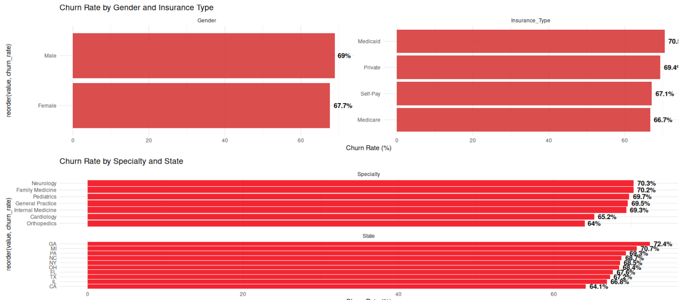

4.3.1.3 Numerical Variables: Descriptive Statistics

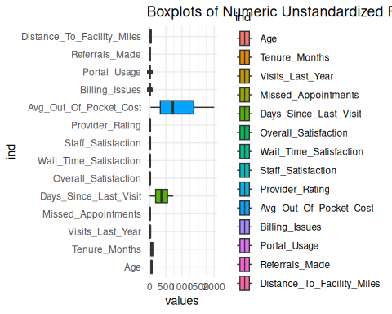
Avg_Out_Of_Pocket_Cost and Days_Since_Last_Visit have very wide ranges and long upper whiskers: high costs and long distances for some patients.
Let’s see what the standardized version of the dataset shows:
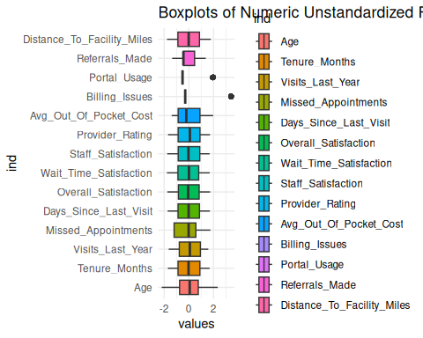
Avg_Out_Of_Pocket_Cost shows the widest spread in the 3rd quartiles and a long upper whisker, indicating significant financial burden for many patients - a likely strong driver of churn.
Distance_To_Facility_Miles is also wide opened not skewed with extreme values, suggesting that patients live all over from the facility. Missed_Appointments has a classic right-skewed meaning the majority of patients are reliable (low/zero misses).
Billing_Issues and Portal_Usage are binary so they are fitting well in this boxplot.

4.3.1.4 Numerical Variables: Histograms
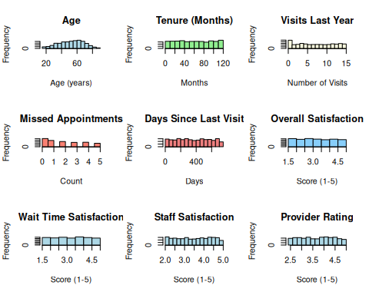
Age shows a roughly symmetric, slightly left-skewed distribution centered around 50-60 years, with most patients between 30 and 70 years old. Middle age patients. Tenure_Months is approximately uniform across 0 to 120 months (10 years), indicating a relatively even spread of patient loyalty durations; No strong concentration of very new or very long-term patients. Visits_Last_Year is right-skewed with a peak at 0-1 visits and a long tail up to 15+, showing that a large portion of patients have low annual utilization, while a smaller group visits frequently. Missed_Appointments is strongly right-skewed: the majority of patients have 0 missed appointments, with a decline as the count increases. This highlights a small repeated no-shows, a signal of Churn risk. Days_Since_Last_Visit shows a wide, roughly uniform spread from 0 to 800+ days, highly variable.

4.3.2 Bivariate Analysis
This section examines the relationship between individual predictors and the binary outcome Churned (1 = churned, 0 = retained). We use appropriate visualizations, descriptive comparisons, and inferential statistics to identify which variables show meaningful differences between retained and churned patients.

4.3.2.1 Numeric Variables vs. Churned
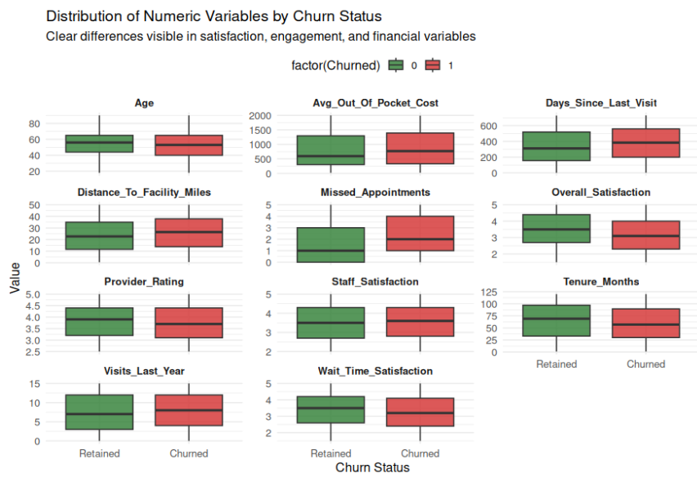
The boxplots reveal several meaningful differences between retained and churned patients. Churned patients tend to report lower satisfaction across Overall Satisfaction, Wait Time Satisfaction, and Provider Rating. They also show signs of reduced engagement, with higher Days Since Last Visit, slightly more Missed Appointments, and shorter Tenure_Months.
Additionally, churned patients have a higher average Out Of Pocket Cost and live slightly farther from the facility (Distance To Facility Miles).
In contrast, variables such as Age and Visits Last Year show smaller or overlapping distributions, suggesting weaker bivariate relationships. These patterns support the hypothesis that service experience quality, recent engagement, and financial/access barriers are key factors associated with higher churn risk.

4.3.2.2 Categorical Variables vs. Churned
This was already discuss on point ##5.1.1 Categorical Data Counts from the univariate section showing the faceted bar chart
This section high the following variables: “Gender”, “Insurance_Type”, “Specialty”, “State”

Variable | Category | n | churn_rate
Gender | Male | 1016 | 0.690
Gender | Female | 984 | 0.677
Insurance_Type | Medicaid | 478 | 0.705
Insurance_Type | Private | 483 | 0.694
Insurance_Type | Self-Pay | 523 | 0.671
Insurance_Type | Medicare | 516 | 0.667
Specialty | Neurology | 286 | 0.703
Specialty | Family Medicine | 289 | 0.702
Specialty | Pediatrics | 284 | 0.697
Specialty | General Practice | 302 | 0.695
Specialty | Internal Medicine | 277 | 0.693
Specialty | Cardiology | 273 | 0.652
Specialty | Orthopedics | 289 | 0.640
State | GA | 181 | 0.724
State | MI | 174 | 0.707
State | PA | 205 | 0.693
State | NC | 259 | 0.687
State | NY | 197 | 0.685
State | OH | 193 | 0.684
State | FL | 213 | 0.676
State | TX | 180 | 0.672
State | IL | 214 | 0.668
State | CA | 184 | 0.641

Churn rates remain consistently high ( 64%-72%) across all categorical variables with very limited variation. Gender shows almost identical churn proportions between males and females. Among insurance types, Medicaid has the highest churn rate (70.5%), while Medicare has the lowest (66.7%). Specialty and State also display modest differences, but no category deviates substantially from the overall churn rate of 68.35%. This lack of strong differentiation is consistent with non-significant Chi-square tests and low effect sizes. It indicates that demographic and administrative factors (Gender, State, Specialty, Insurance_Type) have weak bivariate associations with churn compared to behavioral and experiential variables.

4.3.3 Summary of Relevant Variables for Churn Prediction
To understand which variables differ meaningfully between patients who were Retained and those who Churned, we compute the following for each numeric predictor:
- Mean_Retained: the average value of the variable among patients who remained.
- Mean_Churned: the average value among patients who churned.
- p_value: the probability of observing a difference at least as extreme as the one in our data, assuming no true difference exists.
- Significance: a conventional indicator of statistical evidence (, , ).
This analysis helps identify variables whose distributions differ across churn outcomes, which is essential for both understanding the underlying behavioral patterns and selecting features for predictive modeling.

4.3.4 Statistical Meaning
For each variable, we conduct an independent-samples t-test comparing Retained vs. Churned groups.
- Null Hypothesis (H0):
The mean of the variable is the same for Retained and Churned patients.
$$H_{0}:mu_{R}etained=mu_{C}hurned$$
- Alternative Hypothesis (H1):
The mean differs between the two groups.
$$H_{1}:mu_{R}etained!=mu_{C}hurned$$
A small p‑value indicates evidence against the null hypothesis, suggesting that the variable differs systematically between groups and may be relevant for predicting churn.
While p‑values quantify statistical evidence, the direction and magnitude of the mean differences provide substantive insight into how patient behavior or experience relates to churn.

4.3.5 Compute means, p-values, Cohen’s d, significance
## # A tibble: 14 × 6
## Variable Mean_Retained Mean_Churned p_value Cohen_d Significance
## <chr> <dbl> <dbl> <dbl> <dbl> <chr>
## 1 Overall_Satisfaction 3.48 3.15 5.36e-12 0.335 ***
## 2 Days_Since_Last_Vis… 339. 379. 1.15e- 4 -0.186 ***
## 3 Wait_Time_Satisfact… 3.41 3.24 3.65e- 4 0.171 ***
## 4 Tenure_Months 64.8 58.8 3.65e- 4 0.172 ***
## 5 Distance_To_Facilit… 23.6 25.9 7.80e- 4 -0.162 ***
## 6 Portal_Usage 0.250 0.186 1.61e- 3 0.158 **
## 7 Missed_Appointments 1.85 2.11 1.62e- 3 -0.150 **
## 8 Age 54.3 52.2 3.88e- 3 0.136 **
## 9 Billing_Issues 0.0569 0.0885 8.44e- 3 -0.118 **
## 10 Avg_Out_Of_Pocket_C… 788. 859. 1.06e- 2 -0.121 *
## 11 Provider_Rating 3.79 3.71 1.38e- 2 0.117 *
## 12 Visits_Last_Year 7.26 7.78 2.16e- 2 -0.111 *
## 13 Referrals_Made 1.55 1.45 7.27e- 2 0.0861 ns
## 14 Staff_Satisfaction 3.49 3.54 1.58e- 1 -0.0679 ns

4.3.6 Interpretation
The statistical comparison between retained and churned patients highlights several meaningful differences across key variables. Among the strongest indicators of churn are: Overall_Satisfaction,
Days_Since_Last_Visit,
Wait_Time_Satisfaction,
Tenure_Months, and
Distance_To_Facility_Miles, all of which show highly significant differences (p < 0.001).
For example, retained patients report a higher average overall satisfaction score (3.48)
compared to churned patients (3.15), suggesting that lower satisfaction with care experience is associated with a higher likelihood of leaving the provider. A similar pattern is observed for wait-time satisfaction, where retained patients report a mean score of 3.41 compared to 3.24 among churned patients.
Engagement-related variables also show clear differences. The average number of days since the last visit is higher among churned patients (378.6 days) compared to retained patients (339.1 days), indicating reduced recent interaction with the healthcare system before churn occurs. Similarly, retained patients have a longer tenure with the provider (64.8 months) than churned patients (58.8 months), suggesting that longer relationships with the provider reduce churn risk.
Accessibility and financial factors also appear to contribute to patient attrition. Churned patients live slightly farther from the healthcare facility (25.9 miles) compared to retained patients (23.6 miles), and they incur higher average out-of-pocket costs ($859) compared to retained patients ($787). These results suggest that logistical barriers and financial burden may play a role in patient churn decisions.
Behavioral variables also show statistically significant differences. Churned patients have slightly more missed appointments (2.11) than retained patients (1.85) and lower portal usage (0.19 vs. 0.25), which may reflect lower engagement with healthcare services.
Although many variables are statistically significant, the effect sizes (Cohen’s d) are generally small to moderate, ranging from approximately 0.11 to 0.33 in absolute value. This indicates that no single predictor strongly explains patient churn on its own. Instead, churn behavior appears to result from the combined influence of multiple factors related to patient experience, engagement patterns, accessibility, and financial burden.
In contrast, some variables such as Referrals_Made and Staff_Satisfaction do not show statistically significant differences between retained and churned patients, suggesting that these factors may play a limited role in explaining attrition individually.
Overall, these results indicate that patient churn is primarily driven by experience quality, engagement recency, and access-related barriers, rather than demographic or administrative characteristics alone.
This approach treats churn as a simple binary outcome, ignoring a critical dimension of the problem: time.
In reality, churn is not merely a yes/no event - it is a time-to-event process. Patients churn at different points in their lifecycle, and the timing of churn carries essential information about risk, engagement, and the underlying hazard structure.
For example:
- A patient who churns after 6 months is fundamentally different from one who churns after 5 years.
- Variables such as Tenure_Months, Days_Since_Last_Visit, and Visits_Last_Year are inherently temporal and cannot be fully understood without modeling the time dimension.
- The hazard of churn may not be constant; it may accelerate or decelerate depending on satisfaction, engagement, or access barriers.
Because of this, we move beyond simple group comparisons and adopt a survival analysis framework, which allows us to model:
- time until churn,
- censoring (patients who have not yet churned),
- hazard rates (instantaneous risk of churn), and
- how predictors shift the hazard over time.
Survival models such as the Cox proportional hazards model provide a richer and more realistic understanding of churn dynamics.
In the next section, we develop some Machine learning and survival models to quantify how patient characteristics influence the timing and risk of churn.

5 Predictive Modeling Framework
While the statistical comparisons provide valuable insights into variables associated with churn, they evaluate predictors individually and do not account for interactions between variables, nonlinear relationships, or the combined predictive power of multiple features. To better understand these complex relationships, the analysis proceeds with predictive modeling techniques.
Supervised machine learning models allow predictors to be evaluated jointly rather than independently, enabling the detection of complex patterns that cannot be captured through simple statistical comparisons. In this study, several classification algorithms are implemented to predict patient churn and compare their predictive performance. These models include methods such as
- Logistic Regression,
- Linear ,…,
- and other machine learning algorithms introduced in the course workshops.
To ensure robust evaluation, the modeling process follows standard machine learning procedures including:
- train-test data splitting,
- cross-validation, and
- hyperparameter tuning.

Model performance is evaluated using metrics such as accuracy, precision, recall, and ROC-AUC, allowing the identification of the model that best predicts patient churn.
However, predicting whether a patient churns is only one aspect of the problem. In practice, patient attrition also involves a temporal dimension, since patients may leave at different stages of their relationship with the healthcare provider.
To incorporate this time dimension, the analysis also considers survival analysis techniques, which model time until churn occurs rather than treating churn as a simple binary outcome. Survival models account for:
- the timing of churn events,
- censored observations (patients who have not yet churned), and
- the hazard rate, representing the instantaneous risk of churn.

In particular, the Cox proportional hazards model is used to examine how patient characteristics influence the timing and risk of attrition over time.
By combining exploratory analysis, machine learning classification models, and survival analysis, this study provides a comprehensive framework for understanding both the drivers and dynamics of patient churn.

6. Methodology
This section describes the end-to-end modeling framework used to predict patient churn. The approach follows a structured pipeline that includes data preparation, preprocessing, model specification, resampling-based evaluation, and comparative assessment. The methodology is designed to ensure robustness, reproducibility, and fair comparison across models.

6.1 Data Preparation and Splitting Strategy
The dataset was first loaded and preprocessed using a custom utility function (prepare_churn), which standardizes the structure of the data and ensures consistency of the target variable. The target variable, Churned, is treated as a categorical outcome suitable for classification tasks.
To evaluate model performance, the dataset was partitioned into:
- training set (80%): used for model fitting and cross-validation
- test set (20%): reserved for final out-of-sample evaluation
A stratified sampling strategy was applied during the split to preserve the class distribution of the target variable. This is particularly important given the moderate class imbalance (68% churned vs. 32% retained), ensuring that both subsets remain representative of the original data.
To further improve robustness, 5-fold cross-validation was implemented on the training set. In this approach, the training data is divided into five subsets, and each subset is used once as a validation fold while the remaining data is used for training. This allows the model to be evaluated across multiple data partitions, reducing variance in performance estimates and limiting overfitting.

6.2 Preprocessing Strategy (Recipe Design)
Data preprocessing was implemented using the recipes framework, which provides a systematic and reproducible way to transform data prior to modeling. The preprocessing pipeline was applied consistently across all models to ensure fair comparison.
The following transformations were included:
- Handling novel categories (step_novel)
Ensures that unseen categorical levels in the test set are handled appropriately.
- Handling unknown values (step_unknown)
Replaces missing categorical values with a consistent placeholder.
- One-hot encoding (step_dummy)
Converts categorical variables into binary indicators suitable for machine learning models.
- Removal of zero-variance predictors (step_zv)
Eliminates predictors with no variability, which do not contribute to model learning.
- Normalization of numeric variables (step_normalize)
Scales numeric features to have mean zero and unit variance. This is particularly important for models such as XGBoost and distance-based methods, ensuring that all features contribute equally.
This preprocessing strategy ensures that the dataset is transformed into a model-ready format, while maintaining consistency across different algorithms.

6.3 Model Selection and Specification
Three classification models were selected to represent different levels of complexity and modeling assumptions:
1. Logistic Regression
A generalized linear model (GLM) was used as a baseline. Logistic regression provides:
- high interpretability
- stable performance
- probabilistic outputs
It assumes a linear relationship between predictors and the log-odds of the outcome.

2. Random Forest
Random Forest is an ensemble learning method based on decision trees and bagging. It:
- captures nonlinear relationships
- handles interactions between variables
- is robust to noise and overfitting
A total of 500 trees were used to ensure stable performance.

3. XGBoost (Extreme Gradient Boosting)
XGBoost is a boosting-based ensemble method that sequentially builds trees to minimize prediction error. It:
- captures complex nonlinear patterns
- often achieves high predictive accuracy
- includes built-in regularization mechanisms

Model Selection Strategy
The selected models represent a progression of complexity:
- Logistic Regression → linear, interpretable baseline
- Random Forest → nonlinear ensemble (bagging)
- XGBoost → advanced boosting method
This design allows for a structured comparison of:
- interpretability vs. performance
- linear vs. nonlinear modeling
- simple vs. complex algorithms

6.4 Workflow-Based Modeling Framework
The modeling process was implemented using the tidymodels workflow framework, which integrates preprocessing and model specification into a unified structure.
A workflow set was created to combine:
- the preprocessing recipe
- each model specification
This approach ensures that:
- all models use identical preprocessing
- comparisons are fair and consistent
- the pipeline remains reproducible
The workflow-based approach also simplifies experimentation and reduces the risk of data leakage, as transformations are applied within each resampling iteration.

6.5 Model Training and Resampling
Model training was conducted using the fit_resamples() function, which applies each workflow across the cross-validation folds.
Key characteristics of this approach:
- models are trained and validated on multiple splits
- performance metrics are averaged across folds
- variability in results is reduced
The use of cross-validation ensures that model evaluation is not dependent on a single train-test split and provides a more reliable estimate of generalization performance.

6.6 Evaluation Metrics
To assess model performance, multiple evaluation metrics were used:
- Accuracy: proportion of correct predictions
- Sensitivity (Recall): ability to correctly identify churned patients
- Specificity: ability to correctly identify retained patients
- F1-score: balance between precision and recall
- ROC AUC: overall ability to discriminate between classes
Among these, ROC AUC was selected as the primary metric because:
- it is robust to class imbalance
- it evaluates performance across all classification thresholds
- it provides a global measure of model discrimination
Sensitivity is also emphasized due to the importance of detecting at-risk patients in a healthcare context.

6.7 Model Comparison Strategy
After training, model performance was aggregated using: collect_metrics(models_fitted)
This function computes the mean performance across all cross-validation folds for each model.
The comparison focuses on:
- overall discrimination (ROC AUC)
- trade-off between sensitivity and specificity
- consistency across folds
This structured evaluation allows for the selection of the most appropriate model based on both predictive performance and practical considerations.

6.8 Summary of Methodological Approach
The methodology follows a robust and reproducible pipeline:
- Data preparation and stratified splitting
- Consistent preprocessing using recipes
- Selection of models with increasing complexity
- Integration using workflow sets
- Cross-validation for reliable performance estimation
- Multi-metric evaluation with emphasis on ROC AUC
This framework ensures that model comparisons are fair, interpretable, and aligned with the objectives of predicting patient churn.

7.1 Cross-Validation Performance Overview
The performance of the three models-Logistic Regression, Random Forest, and XGBoost-was evaluated using 5-fold cross-validation. The results are summarized using multiple classification metrics, including accuracy, sensitivity, specificity, F1-score, and ROC AUC.
Overall, the models exhibit moderate predictive performance, with ROC AUC values ranging from approximately 0.606 to 0.648, indicating a limited but meaningful ability to discriminate between churned and retained patients.
## # A tibble: 15 × 9
## wflow_id .config preproc model .metric .estimator mean n std_err
## <chr> <chr> <chr> <chr> <chr> <chr> <dbl> <int> <dbl>
## 1 base_rec_logis… pre0_m… recipe logi… accura… binary 0.681 5 0.00657
## 2 base_rec_logis… pre0_m… recipe logi… f_meas binary 0.292 5 0.0289
## 3 base_rec_logis… pre0_m… recipe logi… roc_auc binary 0.648 5 0.00695
## 4 base_rec_logis… pre0_m… recipe logi… sens binary 0.211 5 0.0260
## 5 base_rec_logis… pre0_m… recipe logi… spec binary 0.898 5 0.0101
## 6 base_rec_rando… pre0_m… recipe rand… accura… binary 0.686 5 0.00515
## 7 base_rec_rando… pre0_m… recipe rand… f_meas binary 0.140 5 0.0174
## 8 base_rec_rando… pre0_m… recipe rand… roc_auc binary 0.635 5 0.00966
## 9 base_rec_rando… pre0_m… recipe rand… sens binary 0.0810 5 0.0113
## 10 base_rec_rando… pre0_m… recipe rand… spec binary 0.966 5 0.00687
## 11 base_rec_xgboo… pre0_m… recipe boos… accura… binary 0.660 5 0.00749
## 12 base_rec_xgboo… pre0_m… recipe boos… f_meas binary 0.313 5 0.0127
## 13 base_rec_xgboo… pre0_m… recipe boos… roc_auc binary 0.606 5 0.0113
## 14 base_rec_xgboo… pre0_m… recipe boos… sens binary 0.245 5 0.0132
## 15 base_rec_xgboo… pre0_m… recipe boos… spec binary 0.853 5 0.0118
Table 7.1 – Metrics Collected for the models_fitted

Table 7.2 below summarizes approximate mean performance values observed in the cross‑validation metric plots. These values are visually estimated to support qualitative comparison.

Model | Accuracy | Sensitivity | Specificity | F1‑Score | ROC AUC
Random Forest | ~0.69 | ~0.07 | ~0.95 | ~0.14 | ~0.63
Logistic Regression | ~0.68 | ~0.21 | ~0.90 | ~0.29 | ~0.65
Boosted Tree | ~0.66 | ~0.24 | ~0.85 | ~0.31 | ~0.60
Table 2: Estimated Cross‑Validation Metric Performance

7.2 Model Comparison
To support interpretation of the workflow metric plots, Table 1 summarizes the mapping between each model, its color as shown in the graphs, and its workflow rank.

Workflow Rank | Model Name | Plot Color
1 | Random Forest | Blue
2 | Logistic Regression | Green
3 | Boosted Tree (XGBoost) | Orange
Table 7.2 Model, Color, and Workflow Rank Mapping

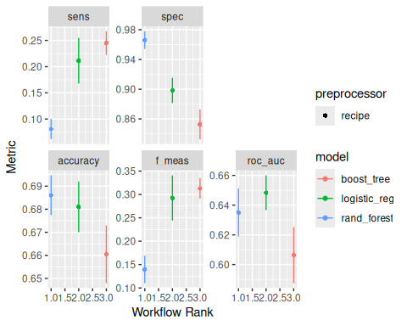
Figure 7.2 – workflow rank between models

Logistic Regression
Logistic Regression achieves the highest ROC AUC (0.648) among all models, indicating the strongest overall discriminatory power. It also demonstrates a balanced performance profile, with:
- Accuracy: 0.681
- Sensitivity: 0.211
- Specificity: 0.898
- F1-score: 0.292

While sensitivity remains relatively low, it is significantly higher than that of the Random Forest model, suggesting that Logistic Regression is more effective at identifying churned patients. Its relatively high specificity indicates strong performance in correctly identifying retained patients.

Random Forest
Random Forest achieves the highest accuracy (0.686) and very high specificity (0.966), indicating strong performance in identifying retained patients. However, this comes at the cost of extremely low sensitivity:
- Sensitivity: 0.081
- F1-score: 0.140
- ROC AUC: 0.635

This result suggests that the model is strongly biased toward the majority class, failing to adequately detect churned patients. Despite its high accuracy, this behavior limits its practical usefulness in a churn prediction context, where identifying at-risk patients is a priority.

XGBoost
XGBoost demonstrates a different performance profile, with:
- Sensitivity: 0.245 (highest among models)
- F1-score: 0.313 (highest among models)
- ROC AUC: 0.606
- Accuracy: 0.660
This indicates that XGBoost is more aggressive in identifying churned patients, resulting in higher sensitivity and F1-score. However, this comes at the expense of lower specificity (0.853) and lower overall discrimination (ROC AUC).

7.3 Trade-Off Between Sensitivity and Specificity
The results highlight a clear trade-off between sensitivity and specificity across models:
- Random Forest prioritizes specificity, minimizing false positives but missing most churners
- XGBoost prioritizes sensitivity, identifying more churners but increasing false positives
- Logistic Regression provides the most balanced trade-off between the two
This trade-off is visualized in Figure 7.2, where Logistic Regression consistently occupies a middle position across all metrics, demonstrating stable and balanced performance.

7.4 Interpretation of ROC AUC
ROC AUC is used as the primary model selection criterion due to its robustness to class imbalance and its ability to evaluate model performance across all classification thresholds.
The results show:
- Logistic Regression: 0.648 (best)
- Random Forest: 0.635
- XGBoost: 0.606
Although the differences are relatively small, Logistic Regression consistently outperforms the other models in terms of overall discrimination.

7.5 Model Selection
Based on the cross-validation results, Logistic Regression is selected as the final model. This decision is justified by:
- the highest ROC AUC
- a balanced sensitivity-specificity trade-off
- stable performance across folds
- high interpretability, which is critical in healthcare applications

While Random Forest achieves slightly higher accuracy, its inability to detect churned patients significantly limits its usefulness. Similarly, although XGBoost improves sensitivity, its lower ROC AUC suggests weaker overall discrimination.

These results shows that increasing model complexity does not necessarily lead to better performance. Despite being the simplest model, Logistic Regression outperforms more complex ensemble methods.
This outcome is consistent with earlier statistical findings, which indicated that:
- individual predictors have small effect sizes
- relationships are largely additive rather than strongly nonlinear

This results demonstrate that:
- all models achieve moderate predictive performance
- class imbalance significantly influences model behavior
- Logistic Regression provides the best balance between performance and interpretability

These findings support the use of Logistic Regression as a robust and practical model for patient churn prediction.

7.6 Logistic Regression Threshold Adjustment
Logistic Regression produces probabilistic predictions, where each observation is assigned a probability of belonging to the churned class. By default, a classification threshold of 0.5 is used to convert these probabilities into class labels. However, this default threshold is not necessarily optimal, particularly in imbalanced classification problems such as patient churn prediction.
To better understand the trade-off between different classification outcomes, a range of thresholds from 0.10 to 0.90 was evaluated. For each threshold, performance metrics including accuracy, sensitivity, specificity, and F1-score were computed on the test dataset.
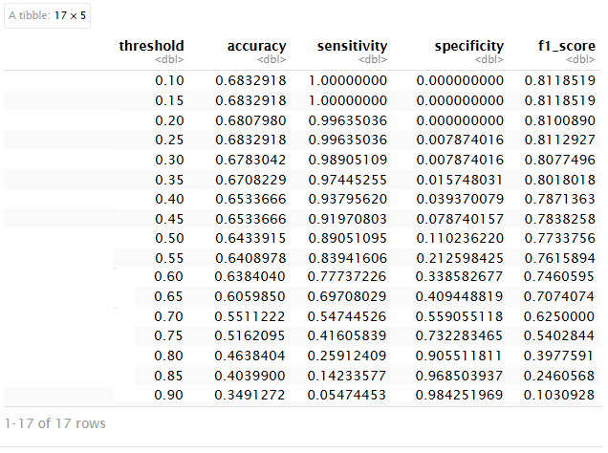
Table 7.7: Logistic Regression Performance Across Thresholds

7.7.1 Threshold–Performance Trade-Off
The results reveal a clear and systematic trade-off between sensitivity and specificity:
- Low thresholds (0.10–0.30)
  - Sensitivity is extremely high (≈ 0.99–1.00)
  - Specificity is near zero
  - The model classifies almost all patients as churned
- Intermediate thresholds (0.40–0.65)
  - Sensitivity gradually decreases
  - Specificity increases
  - The model begins to balance detection of churned and retained patients
- High thresholds (0.70–0.90)
  - Sensitivity becomes low (≈ 0.05–0.55)
  - Specificity becomes high (≈ 0.55–0.98)
  - The model favors identifying retained patients but misses many churners
This behavior reflects the fundamental trade-off in binary classification, where improving one metric often comes at the expense of another.

7.7.2 Optimal Threshold Selection
Based on the results, a threshold around 0.65 provides a practical balance between competing objectives:
Sensitivity | Specificity | Accuracy | F1-score
0.697 | 0.409 | 0.606 | 0.707
Table 7.7.2a: Logistic Regression Performance Metric on 0.65 Thresholds

The choice of classification threshold must align with the operational objective of the model. In this study, the primary goal is early detection of patient churn, meaning that identifying as many at-risk patients as possible is more important than minimizing false positives.
Under this objective, false negatives (missed churners) are significantly more costly than false positives. A missed churned patient represents a lost opportunity for intervention, which may lead to discontinuity of care and reduced patient outcomes. In contrast, false positives may result in unnecessary follow-up actions but generally carry lower operational risk.
For this reason, lower thresholds (such as 0.30) are particularly relevant.
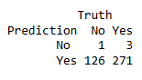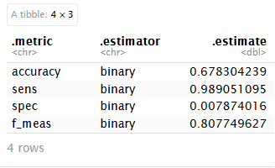

Table 7.7.2b: Logistic Regression Performance Metric on 0.30 Thresholds

At this threshold, the model achieves:
- Sensitivity: 0.989, indicating that nearly all churned patients are detected
- F1-score: 0.808, reflecting strong performance in identifying the positive class
Although specificity is very low, this behavior is consistent with an early-warning system, where the goal is to cast a wide net and identify all potentially at-risk patients.

Based on the analysis, a threshold of 0.30 is selected for this study. This choice reflects a deliberate trade-off:
- maximizing sensitivity to support early intervention
- accepting a higher number of false positives as a manageable cost
This decision aligns with the healthcare context, where proactive engagement and preventive action are prioritized over strict classification accuracy.

8. Survival Analysis
While the previous sections focused on predicting whether a patient will churn, this approach treats churn as a binary outcome, ignoring an important dimension of the problem: time.
In practice, patient churn is not only about if it occurs, but also when it occurs. Two patients may both churn, yet the timing of their disengagement can be fundamentally different. For example, a patient who stops visiting after a few months represents a different risk profile than one who remains engaged for several years before churning.
The classification models developed in this study provide valuable insights into the likelihood of churn. However, they do not capture the temporal dynamics of patient behavior, nor do they account for patients who have not yet churned at the time of observation.
To address these limitations, the analysis is extended to a survival analysis framework, which models churn as a time-to-event process. This approach allows us to:
- estimate the probability that a patient remains active over time
- model the hazard rate, representing the instantaneous risk of churn
- incorporate censored observations, where patients have not yet churned
- better understand how risk evolves throughout the patient lifecycle

By integrating survival analysis with the earlier classification results, this study moves from a static prediction framework toward a dynamic understanding of patient disengagement.

8.2 Cox Proportional Hazards Model
The Cox model is defined as:
$$h(t∣X)=h_{0}(t)exp⁡(βX)$$
where $h(t∣X)$represents the hazard rate conditional on covariates.
8.3 Full Cox Proportional Hazards Model
A full Cox Proportional Hazards model was first estimated using all available predictors in the dataset. This model included demographic variables, geographic location, specialty, insurance type, engagement variables, satisfaction measures, financial indicators, and access-related variables. The objective of fitting the full model was to evaluate the independent association of each predictor with the hazard of patient churn while controlling for all other variables in the model.
Call:
coxph(formula = surv_obj ~ age + gender + state + specialty +
insurance_type + visits_last_year + missed_appointments +
days_since_last_visit + overall_satisfaction + wait_time_satisfaction +
staff_satisfaction + provider_rating + avg_out_of_pocket_cost +
billing_issues + portal_usage + referrals_made + distance_to_facility_miles,
data = cox_data)

n= 2000, number of events= 1367

coef exp(coef) se(coef) z Pr(>|z|)
age -3.184e-03 9.968e-01 1.748e-03 -1.822 0.06851 .
genderMale 1.266e-02 1.013e+00 5.516e-02 0.230 0.81847
stateFL 1.607e-01 1.174e+00 1.257e-01 1.278 0.20132
stateGA 1.545e-01 1.167e+00 1.284e-01 1.203 0.22915
stateIL -5.578e-02 9.457e-01 1.259e-01 -0.443 0.65782
stateMI 1.337e-01 1.143e+00 1.311e-01 1.020 0.30788
stateNC 9.516e-02 1.100e+00 1.204e-01 0.790 0.42940
stateNY 2.278e-01 1.256e+00 1.282e-01 1.776 0.07567 .
stateOH 1.267e-01 1.135e+00 1.287e-01 0.984 0.32495
statePA 2.371e-01 1.268e+00 1.262e-01 1.879 0.06030 .
stateTX 9.787e-02 1.103e+00 1.318e-01 0.743 0.45767
specialtyFamily Medicine 1.009e-01 1.106e+00 1.040e-01 0.970 0.33197
specialtyGeneral Practice -8.914e-02 9.147e-01 1.030e-01 -0.866 0.38657
specialtyInternal Medicine 6.818e-02 1.071e+00 1.054e-01 0.647 0.51789
specialtyNeurology 3.668e-02 1.037e+00 1.057e-01 0.347 0.72849
specialtyOrthopedics -2.882e-02 9.716e-01 1.066e-01 -0.270 0.78695
specialtyPediatrics 2.937e-02 1.030e+00 1.049e-01 0.280 0.77960
insurance_typeMedicare 4.937e-02 1.051e+00 8.820e-02 0.560 0.57565
insurance_typePrivate 8.098e-02 1.084e+00 7.840e-02 1.033 0.30168
insurance_typeSelf-Pay 2.076e-02 1.021e+00 7.732e-02 0.268 0.78833
visits_last_year 8.035e-03 1.008e+00 6.151e-03 1.306 0.19144
missed_appointments 1.690e-02 1.017e+00 1.691e-02 0.999 0.31772
days_since_last_visit 5.028e-04 1.001e+00 1.285e-04 3.914 9.09e-05 ***
overall_satisfaction -9.128e-02 9.128e-01 2.752e-02 -3.317 0.00091 ***
wait_time_satisfaction -8.724e-02 9.165e-01 2.770e-02 -3.149 0.00164 **
staff_satisfaction 4.476e-03 1.004e+00 3.189e-02 0.140 0.88839
provider_rating -5.651e-02 9.451e-01 3.813e-02 -1.482 0.13827
avg_out_of_pocket_cost 4.762e-05 1.000e+00 5.612e-05 0.849 0.39611
billing_issues 6.887e-02 1.071e+00 9.762e-02 0.705 0.48051
portal_usage -1.362e-01 8.726e-01 7.081e-02 -1.924 0.05439 .
referrals_made -5.271e-02 9.487e-01 2.526e-02 -2.087 0.03689 *
distance_to_facility_miles 5.400e-03 1.005e+00 1.990e-03 2.714 0.00665 **
---
Signif. codes: 0 ‘***’ 0.001 ‘**’ 0.01 ‘*’ 0.05 ‘.’ 0.1 ‘ ’ 1

exp(coef) exp(-coef) lower .95 upper .95
age 0.9968 1.0032 0.9934 1.0002
genderMale 1.0127 0.9874 0.9090 1.1284
stateFL 1.1743 0.8516 0.9178 1.5025
stateGA 1.1670 0.8569 0.9073 1.5011
stateIL 0.9457 1.0574 0.7389 1.2105
stateMI 1.1431 0.8748 0.8840 1.4781
stateNC 1.0998 0.9092 0.8686 1.3926
stateNY 1.2558 0.7963 0.9767 1.6146
stateOH 1.1351 0.8810 0.8820 1.4608
statePA 1.2676 0.7889 0.9898 1.6234
stateTX 1.1028 0.9068 0.8518 1.4278
specialtyFamily Medicine 1.1061 0.9040 0.9022 1.3562
specialtyGeneral Practice 0.9147 1.0932 0.7476 1.1192
specialtyInternal Medicine 1.0706 0.9341 0.8707 1.3163
specialtyNeurology 1.0374 0.9640 0.8433 1.2760
specialtyOrthopedics 0.9716 1.0292 0.7883 1.1975
specialtyPediatrics 1.0298 0.9711 0.8384 1.2650
insurance_typeMedicare 1.0506 0.9518 0.8838 1.2489
insurance_typePrivate 1.0843 0.9222 0.9299 1.2645
insurance_typeSelf-Pay 1.0210 0.9795 0.8774 1.1880
visits_last_year 1.0081 0.9920 0.9960 1.0203
missed_appointments 1.0170 0.9832 0.9839 1.0513
days_since_last_visit 1.0005 0.9995 1.0003 1.0008
overall_satisfaction 0.9128 1.0956 0.8648 0.9633
wait_time_satisfaction 0.9165 1.0912 0.8680 0.9676
staff_satisfaction 1.0045 0.9955 0.9436 1.0693
provider_rating 0.9451 1.0581 0.8770 1.0184
avg_out_of_pocket_cost 1.0000 1.0000 0.9999 1.0002
billing_issues 1.0713 0.9334 0.8847 1.2972
portal_usage 0.8726 1.1459 0.7596 1.0026
referrals_made 0.9487 1.0541 0.9028 0.9968
distance_to_facility_miles 1.0054 0.9946 1.0015 1.0093

Concordance= 0.572 (se = 0.009 )
Likelihood ratio test= 78.3 on 32 df, p=9e-06
Wald test = 77.86 on 32 df, p=1e-05
Score (logrank) test = 78.03 on 32 df, p=1e-05

[1] 18194.01

The full model was fitted on 2,000 patients, with 1,367 observed churn events. Overall, the model was statistically significant, as indicated by the likelihood ratio test, Wald test, and score test, all with p-values below 0.001. This suggests that the included predictors, considered jointly, provide meaningful information about churn risk over time. The model produced a concordance value of 0.572, indicating modest discriminative ability, and an AIC of 18194.01, which serves as a baseline for comparison with the reduced Cox model.
The results show that only a subset of variables had statistically significant effects on the hazard of churn. The strongest predictors were days_since_last_visit, overall_satisfaction, wait_time_satisfaction, referrals_made, and distance_to_facility_miles. Specifically, longer time since the last visit was associated with a higher churn hazard, while higher overall satisfaction and higher wait-time satisfaction were associated with lower churn hazard. Similarly, more referrals were associated with reduced churn risk, whereas greater distance to the facility increased the hazard of churn.
In terms of hazard ratios, a one-unit increase in overall satisfaction was associated with a hazard ratio of 0.913, corresponding to an approximate 8.7% decrease in churn risk. Similarly, a one-unit increase in wait-time satisfaction was associated with a hazard ratio of 0.917, or about an 8.3% decrease in churn risk. In contrast, each additional mile from the facility was associated with a hazard ratio of 1.005, indicating a small but statistically significant increase in churn risk. These findings reinforce the central pattern observed in the EDA: patient churn is influenced more by engagement, satisfaction, and access barriers than by demographic or administrative factors.
Although the full model provides a comprehensive view of all predictors, many variables such as gender, insurance type, specialty, billing issues, and most state indicators were not statistically significant. This suggests that a more parsimonious reduced model may provide clearer interpretation while retaining the most important predictors. Therefore, the next step was to estimate a reduced Cox model using only the statistically significant variables identified in the full model.

8.4 Key Drivers of Patient Churn (Full Model)
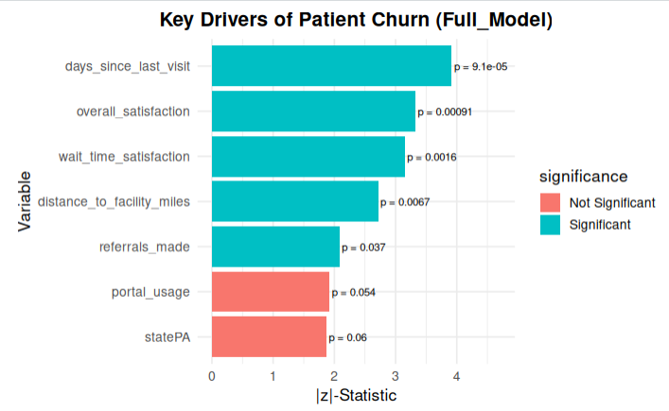
Figure 8.4: Key Drivers of Patient Churn (Full Model)

The results clearly show that the most important drivers of patient churn are:
- Days Since Last Visit (p < 0.001): This variable exhibits the strongest effect, indicating that longer periods of inactivity significantly increase the risk of churn. This confirms that disengagement is a leading indicator of patient attrition.
- Overall Satisfaction (p < 0.001): Higher satisfaction is associated with a lower hazard of churn, emphasizing the critical role of patient experience in retention.
- Wait Time Satisfaction (p < 0.01): Shorter wait times contribute to improved patient retention, reinforcing the importance of operational efficiency.
- Distance to Facility (p < 0.01): Greater distance increases churn risk, highlighting structural barriers to continued care.
- Referrals Made (p < 0.05): Patients who make referrals tend to have lower churn risk, suggesting that engagement and advocacy are strong indicators of loyalty.
In contrast, variables such as portal usage and state (PA) are not statistically significant at the 5% level, although they show moderate effects. These variables may still contribute contextually but do not provide strong independent explanatory power in the presence of other predictors.

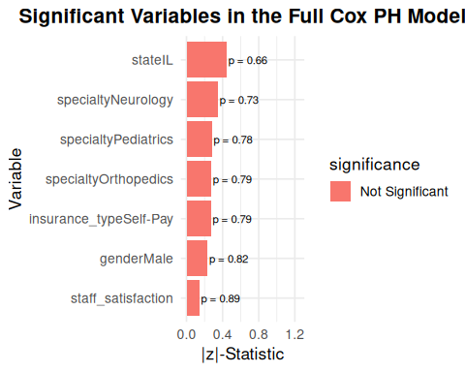
The figure shows that several variables exhibit very low statistical significance, including:
- Gender (Male)
- Staff Satisfaction
- Insurance Type (Self-Pay)
- Medical Specialties (Neurology, Pediatrics, Orthopedics)
- Certain geographic indicators (like the State of IL)
These variables have high p-values (p > 0.05), indicating that their effects on churn risk are not statistically distinguishable from zero when controlling for other variables in the model.

Given that only a subset of variables shows strong statistical significance, the next step is to construct a reduced Cox model that focuses on these key predictors, improving interpretability while maintaining predictive performance.

8.5 Reduced Cox Proportional Hazards Model
To improve interpretability and model efficiency, a reduced Cox Proportional Hazards model was developed by retaining only the statistically significant predictors identified in the full model. The goal of this approach is to focus on the most influential variables while eliminating noise introduced by non-significant factors.
The reduced model includes the following predictors:
- overall satisfaction
- days since last visit
- wait time satisfaction
- referrals made
- distance to facility

This selection aligns with earlier findings from both the exploratory data analysis and classification models, reinforcing the importance of engagement, satisfaction, and accessibility in explaining patient churn.

8.5.1 Model Performance
The reduced model was fitted on the same dataset (n = 2000, with 1367 churn events). All included variables remain statistically significant at the 5% level.
Key model statistics:
- AIC = 18170.73
- Concordance = 0.552
- Likelihood Ratio Test p < 0.001
The reduced model achieves a lower AIC than the full model (18170.73 vs 18194.01), indicating a better balance between model fit and complexity.
Although the concordance decreases slightly (from 0.572 to 0.552), this reduction is minor and expected when simplifying the model.

8.5.2 Interpretation of Key Predictors
The reduced model provides a clearer interpretation of the main drivers of patient churn.
- Overall Satisfaction (HR = 0.912): A one-unit increase in satisfaction reduces churn risk by approximately 8.8%, confirming that patient experience is a critical retention factor.
- Wait Time Satisfaction (HR = 0.914): Shorter perceived wait times similarly reduce churn risk, highlighting the importance of operational efficiency.
- Days Since Last Visit (HR ≈ 1.0005): Although the effect size per unit is small, the variable is highly significant. Over longer periods, inactivity substantially increases churn risk.
- Referrals Made (HR = 0.950): Patients who refer others are less likely to churn, suggesting that engagement and satisfaction are closely linked to loyalty.
- Distance to Facility (HR = 1.005): Greater distance increases churn risk, reflecting structural barriers to accessing care.
Compared to the full model, the reduced model offers several advantages:
- improved interpretability
- reduced complexity
- elimination of non-informative variables
- comparable predictive performance
This makes the model more suitable for practical implementation and decision-making.

The reduced Cox model provides a concise and interpretable representation of the key drivers of churn. By focusing on a small set of meaningful predictors, it enhances both analytical clarity and practical usability.
In the next section, we further validate the model assumptions and explore survival behavior through graphical analysis.
8.6 Survival and Cumulative Hazard Curves
After selecting the reduced Cox model as the best model, survival and cumulative hazard curves were generated to visualize how patient retention and churn risk evolve over time.
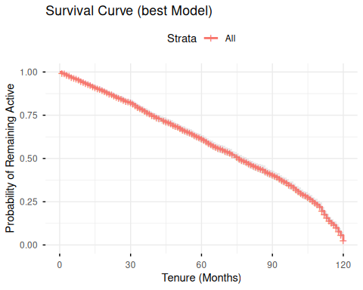
Figure 8.6a: Survival Curve

The survival curve shows the estimated probability that a patient remains active as tenure increases. At the beginning of the observation period, the probability of remaining active is close to 1.00. As tenure progresses, the survival probability steadily declines, indicating that churn risk accumulates over time. By the later months, especially near the end of the 120-month observation window, the probability of remaining active drops sharply.
This pattern suggests that patient churn is not a random or isolated event. Instead, churn appears to be a gradual process in which the likelihood of remaining active decreases over the patient lifecycle.

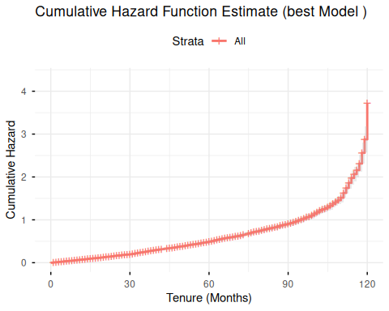
Figure 8.6b: cumulative hazard function estimate

The cumulative hazard curve provides the complementary view of the survival curve. While the survival curve decreases over time, the cumulative hazard curve increases, showing the accumulation of churn risk across tenure months. The curve rises gradually during the early and middle periods, then increases more sharply toward the end of the observation window.
This indicates that churn risk becomes more pronounced as time progresses, particularly among patients with longer observed tenure. The sharp increase near later months may reflect accumulated disengagement, unresolved dissatisfaction, or increased likelihood that patients eventually stop returning to care.
These findings support the use of survival analysis as a complement to classification models. While machine learning models identify which patients are most likely to churn, survival analysis provides insight into when churn risk becomes more pronounced.

8.7 Case Study: Predicted Risk for Two Patient Profiles
To illustrate the practical implications of the Cox model, two hypothetical patient profiles were constructed based on key predictors identified in the reduced model. These profiles represent contrasting levels of churn risk driven by differences in satisfaction, engagement, and accessibility.
- Individual 1 (Lower Risk)
High satisfaction, recent visit (10 days), short distance (5 miles), and active referral behavior
- Individual 2 (Higher Risk)
Low satisfaction, long inactivity (90 days), greater distance (25 miles), and no referrals
Using the fitted Cox model, predicted survival and cumulative hazard functions were generated for both individuals.

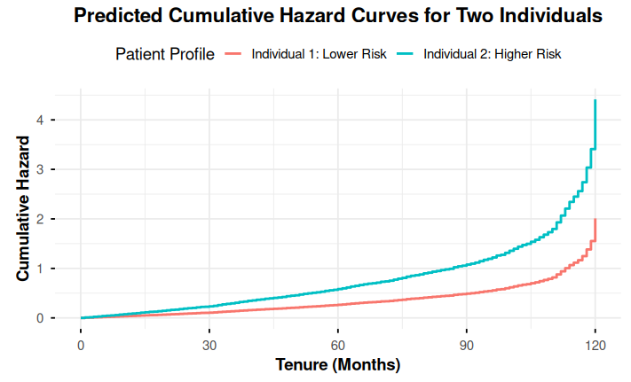
Figure 8.7a: Predicted Cumulative Hazard Curves for Two Individuals

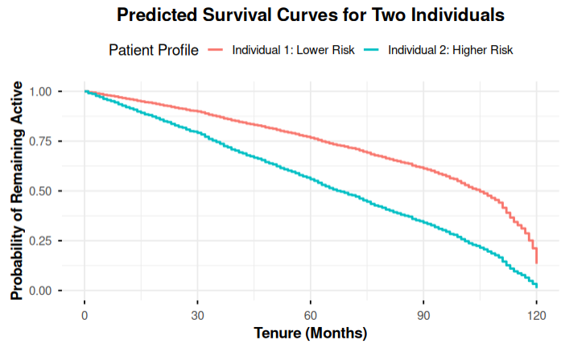
Figure 8.7b: Predicted Cumulative Hazard Curves for Two Individuals

8.7.1 Interpretation of Results
The survival curves
The survival curves show a clear divergence between the two profiles over time.
At approximately 60 months, the estimated survival probabilities are:
- Individual 1 (Lower Risk): 0.767
- Individual 2 (Higher Risk): 0.559
This represents a 21 percentage point difference in the probability of remaining active, demonstrating the substantial impact of patient characteristics on long-term retention.
Over time, this gap continues to widen:
- the low-risk individual maintains a relatively high survival probability
- the high-risk individual experiences a much steeper decline
By the end of the observation period, the high-risk profile approaches near-zero survival probability, indicating a very high likelihood of churn.

The cumulative hazard
The cumulative hazard curves provide a complementary perspective on risk accumulation.
At approximately 75 months, the cumulative hazard values are:
- Individual 1 (Lower Risk): 0.368
- Individual 2 (Higher Risk): 0.808

This indicates that the high-risk individual accumulates more than twice the churn risk compared to the low-risk individual over the same period.
The curves show that:
- risk increases gradually for both individuals
- the increase is significantly steeper for the high-risk profile
- the gap between the two profiles widens over time

8.7.2 Conclusio
This case study highlights a critical finding: small differences in satisfaction, engagement, and access can lead to large differences in long-term patient retention. In particular:
- inactivity (days since last visit) is a major accelerator of churn
- low satisfaction compounds this effect
- distance and lack of engagement further increase risk

From a healthcare perspective, these results provide clear guidance for intervention strategies:
- patients similar to the high-risk profile should be flagged early for outreach
- monitoring recency of visits can serve as an early warning indicator
- improving patient experience (satisfaction and wait time) can significantly reduce churn risk
- addressing access barriers (distance, convenience) may further improve retention

The case study reinforces the conclusions drawn throughout the analysis:
- classification models identified who is likely to churn
- survival analysis explains how quickly churn risk develops

Both approaches consistently highlight the same core drivers: engagement, satisfaction and accessibility.

This case demonstrates the strength of survival analysis as a decision-support tool. By translating statistical results into realistic patient scenarios, the model provides actionable insights that support targeted intervention and improved patient retention strategies.

Conclusion
This study developed a unified framework to analyze patient churn using machine learning and survival analysis. The results show that churn is primarily driven by engagement, satisfaction, and accessibility, rather than demographic factors.
Logistic Regression provided the best balance between performance and interpretability, and threshold tuning allowed the model to function as an early-warning system by prioritizing the detection of at-risk patients. Survival analysis extended these findings by incorporating time, showing that churn risk increases progressively, especially for patients with low satisfaction and long periods of inactivity.
Overall, the study demonstrates that effective churn management requires understanding both who is at risk and when intervention is needed.

Future work could include incorporating time-varying features, applying advanced models such as Random Survival Forests, and developing real-time monitoring systems to support proactive patient retention strategies.

References
Boozary, P., Sheykhan, S., GhorbanTanhaei, H., & Magazzino, C. (2025). Enhancing customer retention with machine learning: A comparative analysis of ensemble models for accurate churn prediction. International Journal of Information Management Data Insights, 5, 100331. https://doi.org/10.1016/j.jjimei.2025.100331

Kimitei, S., Agiro, D., Ni, S., & Ni, H. (2025). Predictability and explainability of survival analysis in churn prediction. Journal of Marketing Analytics. Advance online publication. https://doi.org/10.1057/s41270-025-00450-2

Lee, B. (2025). A comparison study of parametric and machine learning survival analysis models to predict customer churn in the EdTech sector (Diploma thesis, Technische Universität Wien). reposiTUm. https://doi.org/10.34726/hss.2025.124833

Lu, J. (2002). Predicting customer churn in the telecommunications industry: An application of survival analysis modeling using SAS. In Proceedings of the 27th Annual SAS Users Group International Conference (SUGI 27). SAS Institute Inc.

Abbas, N. (n.d.). Patient churn prediction dataset for healthcare. Kaggle. https://www.kaggle.com/datasets/nudratabbas/patient-churn-prediction-dataset-for-healthcare

